**ELB Assignment 1**

**Problem Statement:**

You work for XYZ Corporation that uses on premise solutions and some limited number of systems. With the increase in requests in their application, the load also increases. So, to handle the load the corporation has to buy more systems almost on a regular basis. Realizing the need to cut down the expenses on systems, they decided to move their infrastructure to AWS.

**Tasks To Be Performed:**

1. Create a Classic Load Balancer and register 3 EC2 instances with different web pages running in them.

2. Migrate the Classic Load Balancer into an Application Load Balancer.

**Problem 1 Solution:** Create a Classic Load Balancer and register 3 EC2 instances with different web pages running in them.

**a. Create Three Different EC2 Instances**

**1. Launch First Instance in Default Availability Zone (ap-south-1a)**

***Note: First, you have to create the two separate subnet in that default VPC.***

**Step 1: Go** tothe **“Services” section** & **search** the **“EC2”. Click** onthe **“Instance”.**

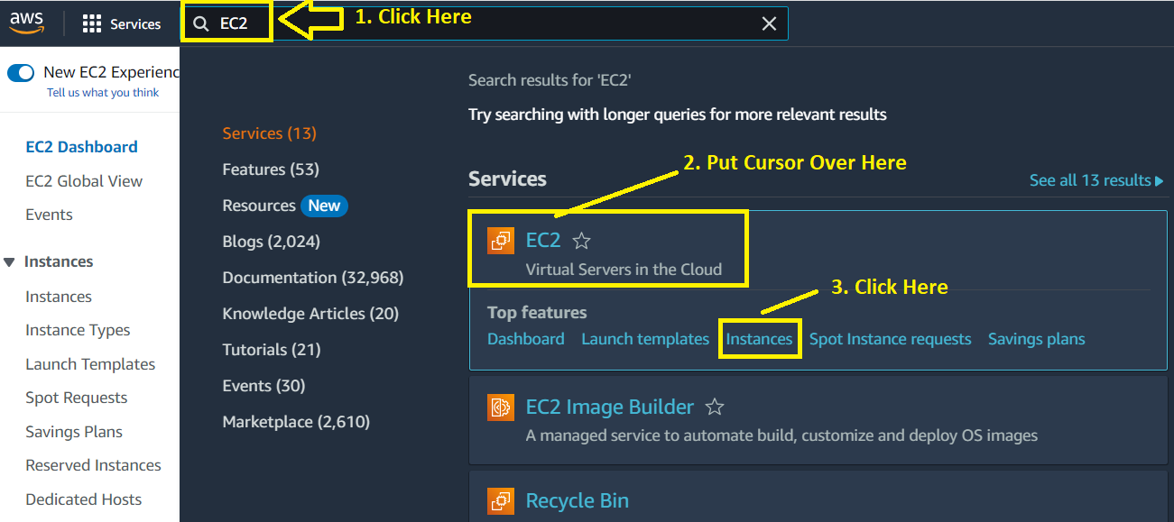

**Step 2: Click** on the **“Launch Instance”.**

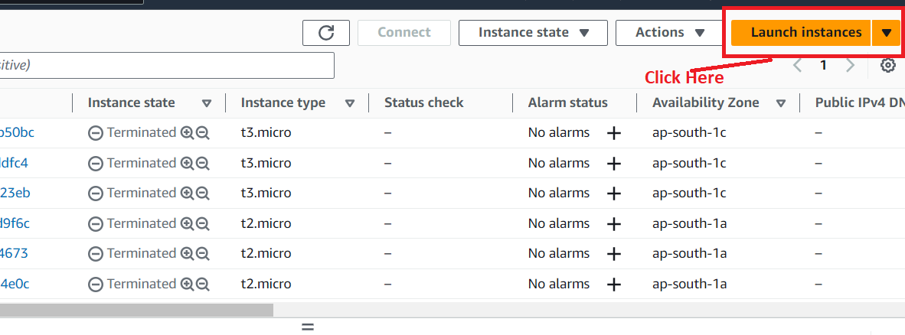

**Step 3: Choose** the **“Name”** as **“AWSClassic1”.**

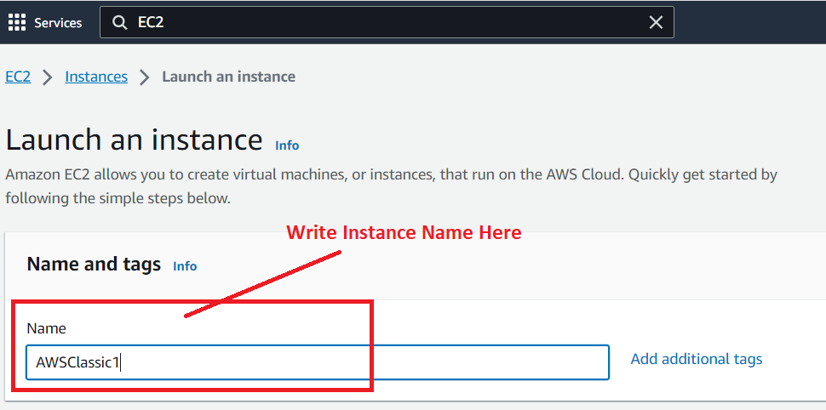

**Step 4: Choose** the **AMI** as **“Amazon Linux 2”** & **choose** the **“AMI Version”** as **“Amazon Linux 2 AMI (HVM) – Kernel 5.10, SSD Volume Type”.**

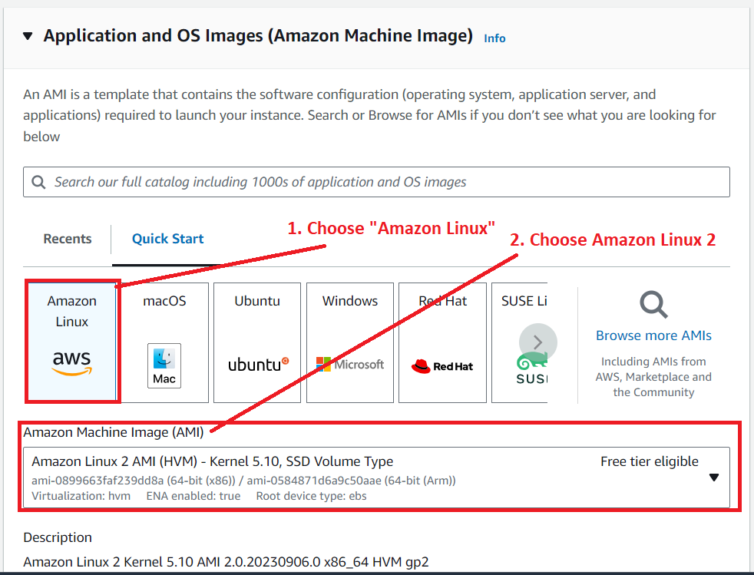

**Step 5: Choose** the **“Instance Type”** as **“t2.micro”. While choose** your **“Key pair (login)** asthe **“MY-WEB-SERVER”. Otherwise, you** can **create** a **new .pem file. We** have **created** this **key pair that’s why we** are **choosing “key pair” here.**

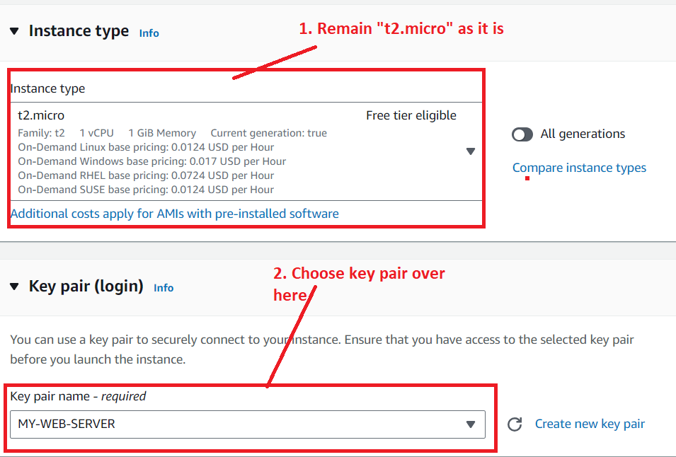

**Step 6: Click** onthe **“Edit”** inthe **“Network Settings”.**

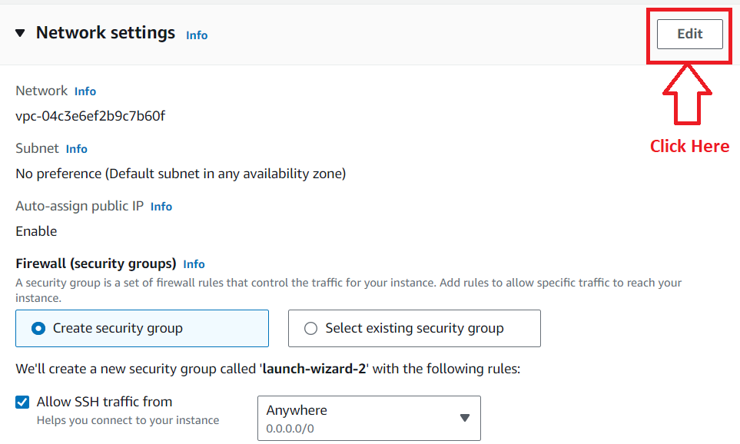

**Step 7: Choose** the **“default subnet (subnet-0012fe787fe8d6766)”, where** the **“Availability Zone”** would be **“ap-south-1a”.**

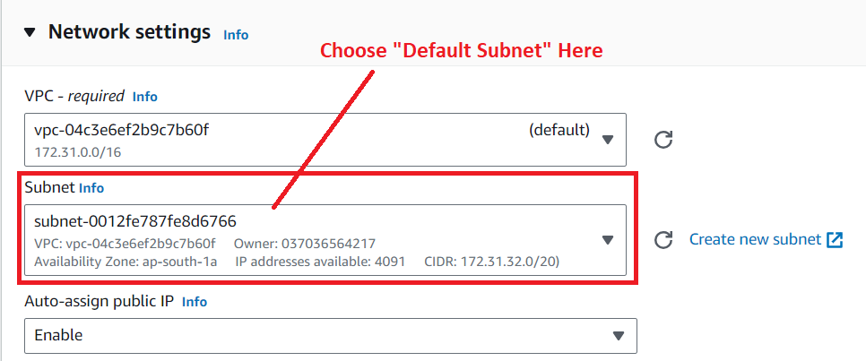

**Step 8: Choose** the **“Create Security Group”** inthe **“Firewall (security groups).**

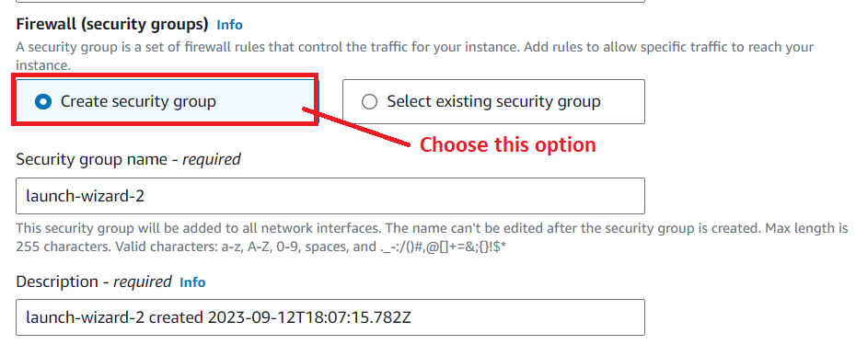

**Step 9: Click** on the **“Add security group rule”** in the **“Inbound Security Group Rules”.**

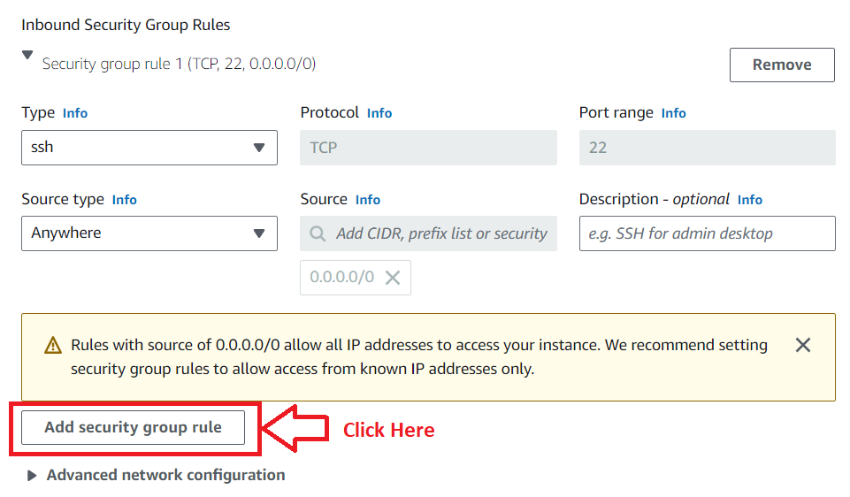

**Step 10: Choose** the **“Type”** as **“HTTP”** &the **“Source Type”** as **“Anywhere”.**

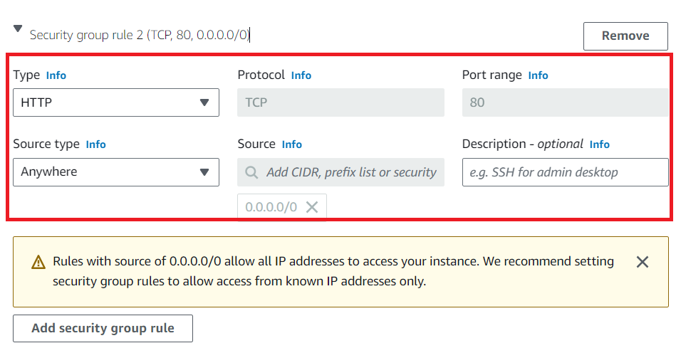

**Step 11: Remain** the **“Configure Storage”** as **it is.**

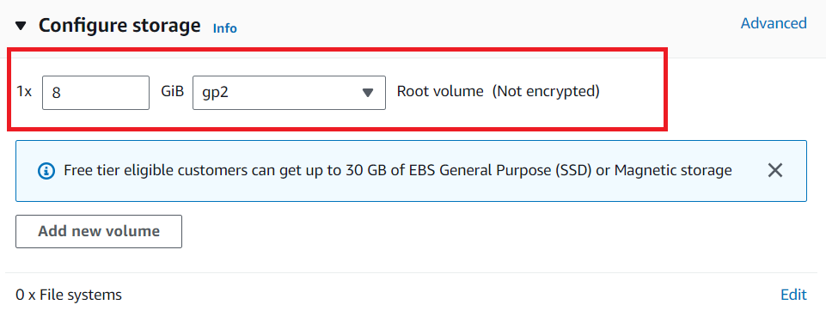

**Step 12: Click** on the **“Advance Details” & put** this **user data** over **here.**

**#!/bin/bash**

**# Use this for your user data (script from top to bottom)**

**# install httpd (Linux 2 version)**

**yum update -y**

**yum install -y httpd**

**systemctl start httpd**

**systemctl enable httpd**

**echo "<h1>Hello World from $(hostname -f)</h1>" > /var/www/html/index.html**

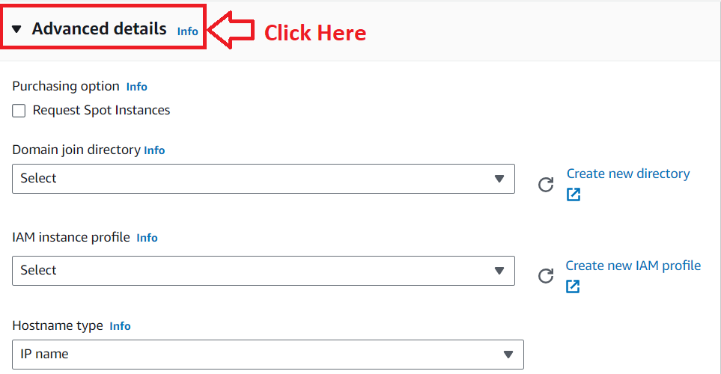

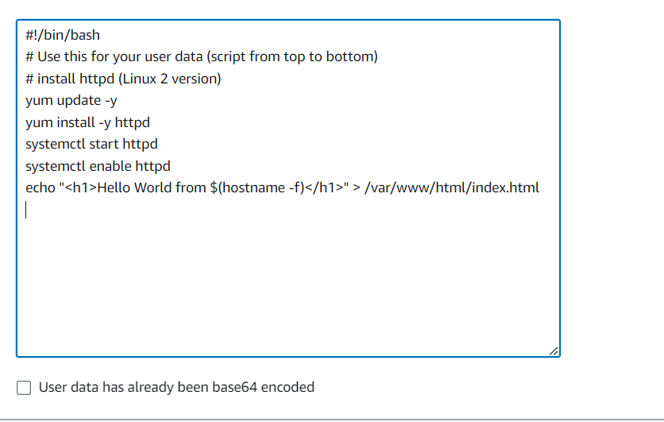

**Step 13: Click** onthe **“Launch Instance”.**

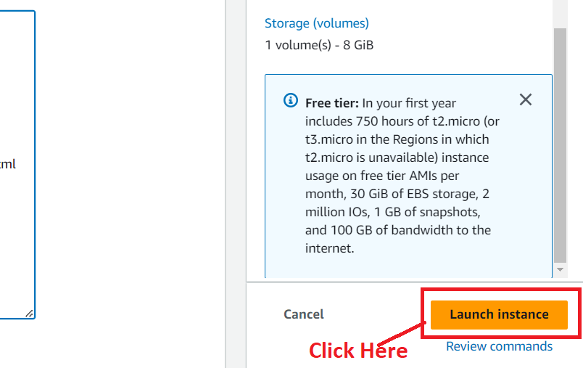

**Step 14: Your instance** will be **successfully launched. Click** onthe **“Hyperlink Id”.**

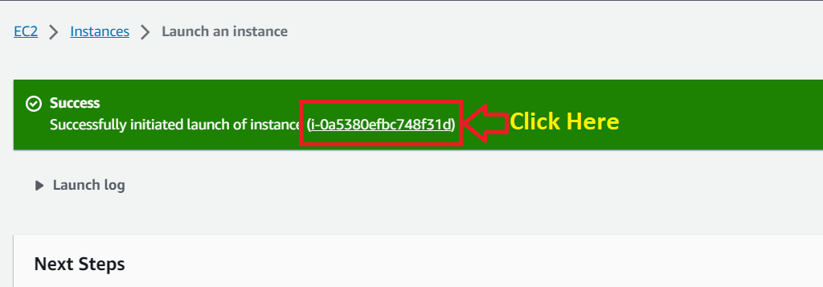

**Step 15: Your instance** will be **shown** as the **“Running”** from **moving** tothe **“Pending” now.**

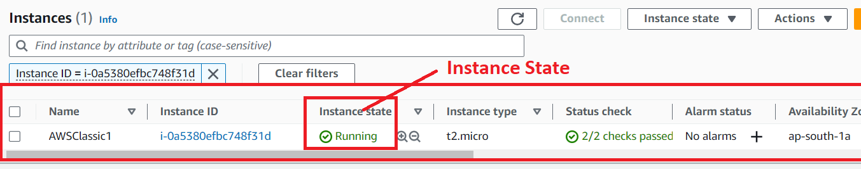

**Step 16: Select** the **Instance** & **copy your “IP Address”** from the **“Public IPv4 address”.**

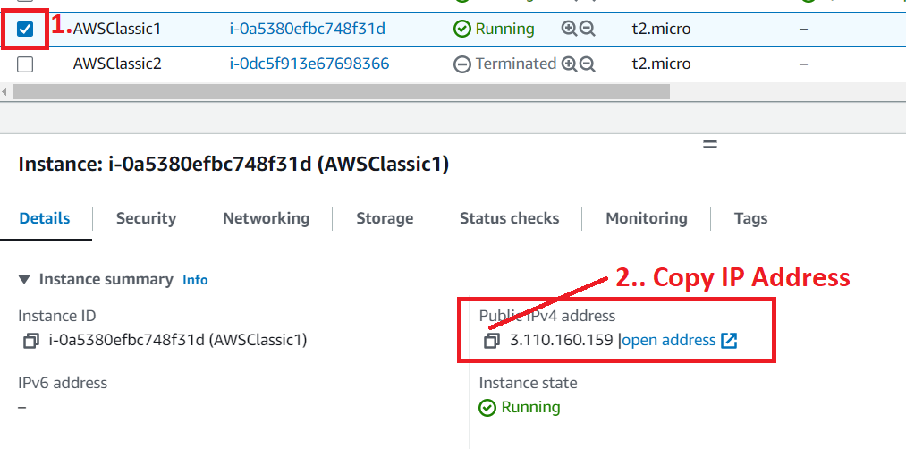

**Step 17: Copy** the **IP Address** & **paste** the **IP Address** in the **browser bar.**

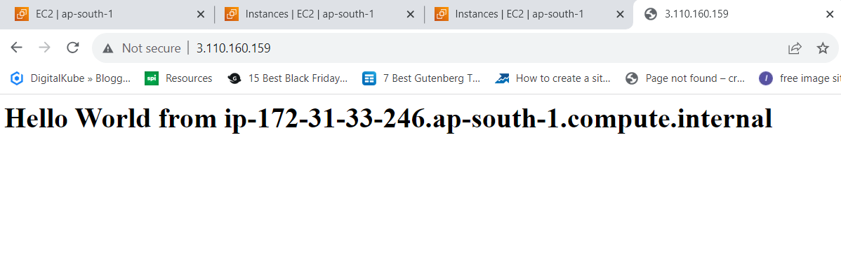

**2. Launch the Second Instance in Other Created Availability Zone (ap-south-1b)**

**Step 1: Click** onthe **“Launch Instance”.**



**Step 2: Choose** the **“Name”** as **“AWSClassic2”.**

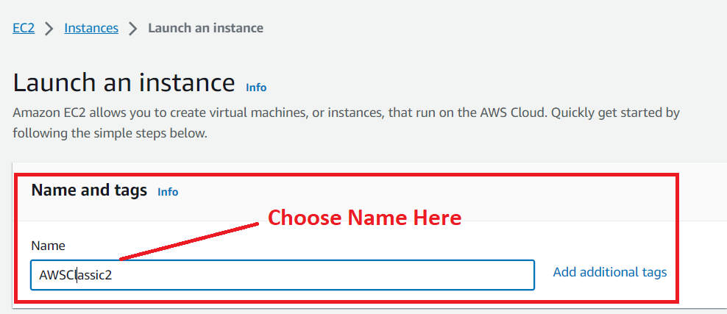

**Step 3: Choose** the **AMI** as **“Amazon Linux 2”** & **choose** the **“AMI Version”** as **“Amazon Linux 2 AMI (HVM) – Kernel 5.10, SSD Volume Type”.**



**Step 4: Remain** the **“Instance Type”** asthe **“t2.micro”. While choose** your **“Key pair (login)** as **“MY-WEB-SERVER”. Otherwise, you** can **create** a **new .pem file. We** have **created** this **key pair that’s why we** are **choosing** the **“key pair”** here.



**Step 5: Click** on the **“Edit”** in the **“Network Settings”.**



**Step 6:  Choose** the **“created subnet (subnet-00cf17266e1b37cef) or Zone_B”, where** the **“Availability Zone”** isthe **“ap-south-1b”.**

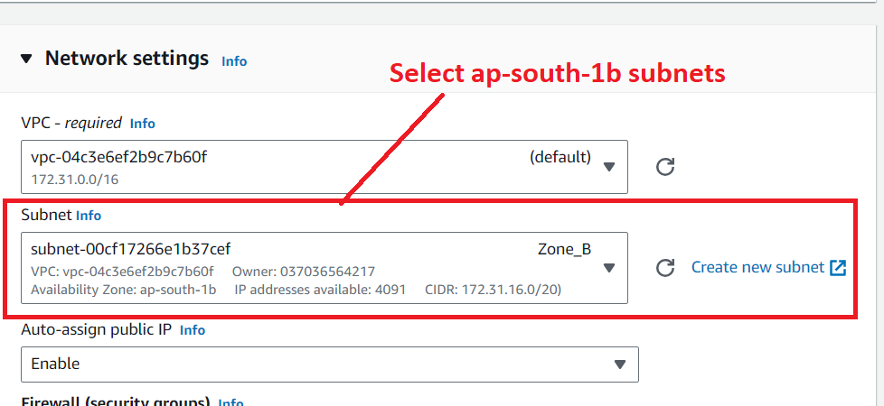

**Step 7: Choose** the **“Select Existing Security Group”** in the **“Firewall (security groups).**

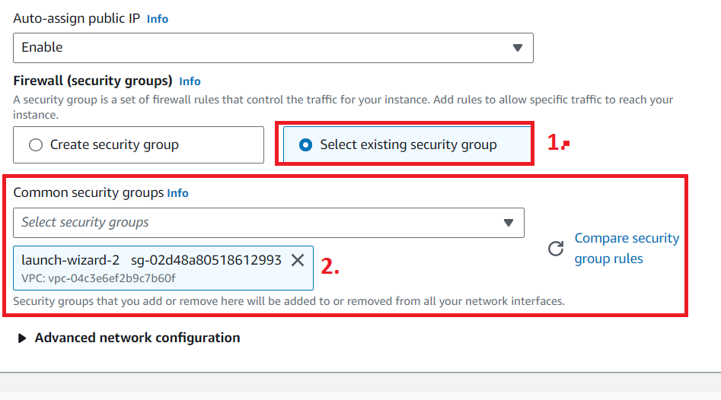

**Step 8: Remain** the **“Configure Storage”** as **it is.**



**Step 9: Click** on the **“Advance Details” & put** this **user data** over **here.**

**#!/bin/bash**

**# Use this for your user data (script from top to bottom)**

**# install httpd (Linux 2 version)**

**yum update -y**

**yum install -y httpd**

**systemctl start httpd**

**systemctl enable httpd**

**echo "<h1>Hello World from $(hostname -f)</h1>" > /var/www/html/index.html**





**Step 10: Click** onthe **“Launch Instance”.**



**Step 11: Your instance** will be **successfully launched. Click** onthe **“Hyperlink Id”.**

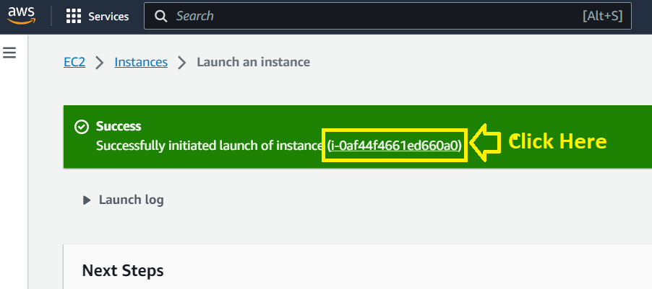

**Step 12: Your instance** will be **shown** as **“Running”** from **moving** to **“Pending” now.**

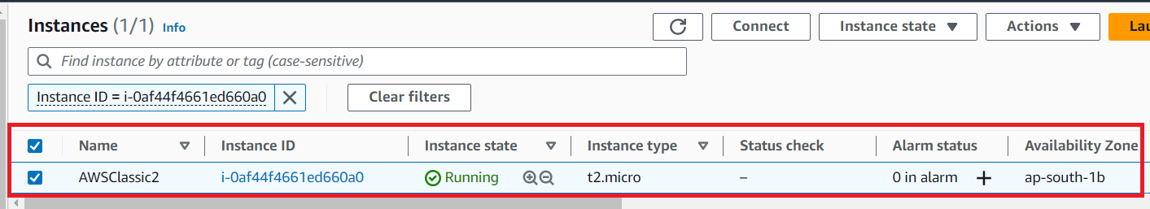

**Step 13: Select** the **Instance** & **you** will **get** your **“Public IPv4 address”. Copy** this **public IP address.**

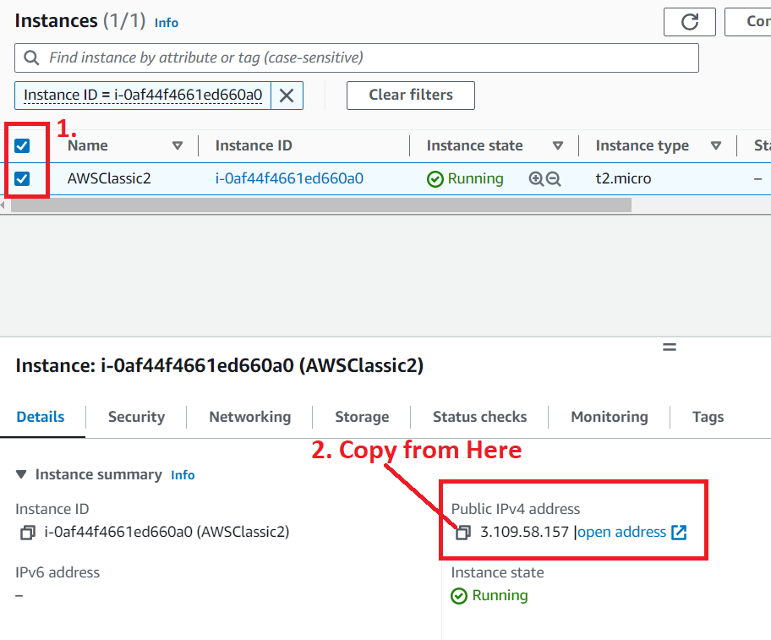

**Step 14: Paste** the **IP Address** inthe **browser address bar** & **you** will have **successfully installed** your **httpd server.**

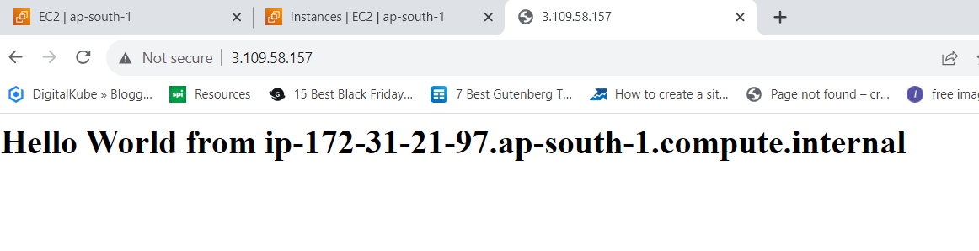

**3. Launch the Third Instance in the Other Created Availability Zone (ap-south-1c)**

**Step 1: Click** on the **“Launch Instance”.**



**Step 2: Choose** the **“Name”** asthe **“AWSClassic3”.**

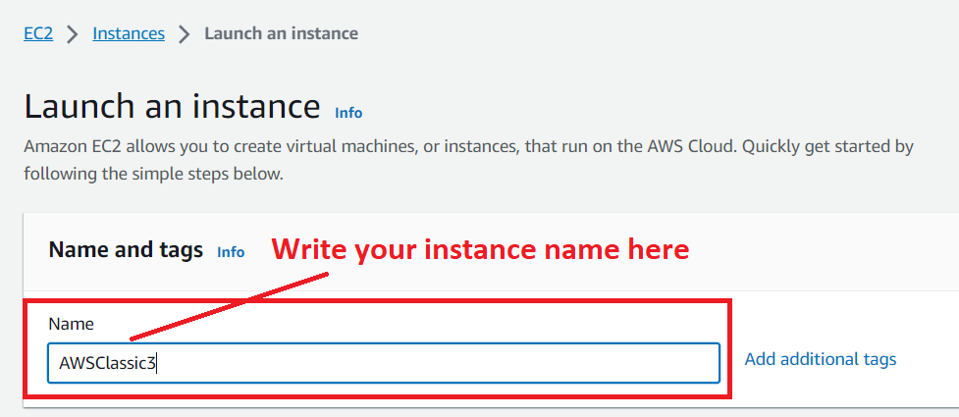

**Step 3: Choose** the **AMI** as **“Amazon Linux 2” & choose** the **“AMI Version”** as **“Amazon Linux 2 AMI (HVM) – Kernel 5.10, SSD Volume Type”.**



**Step 4: Choose** the **“Instance Type” as “t3.micro”. While choose** your **“Key pair (login)** as the **“MY-WEB-SERVER”. Otherwise, you** can **create** a **new .pem file. We** have **created** this **key pair that’s why we** are **choosing** the **“key pair” here.**

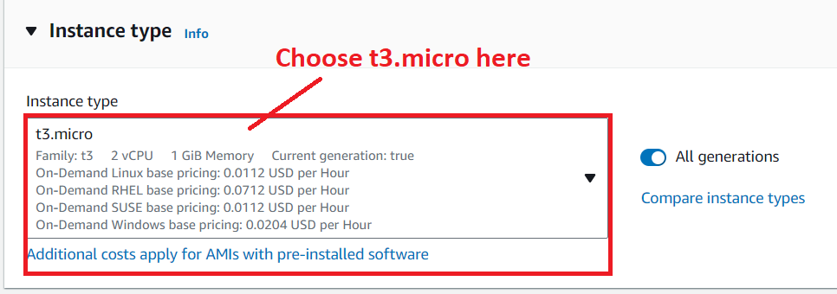

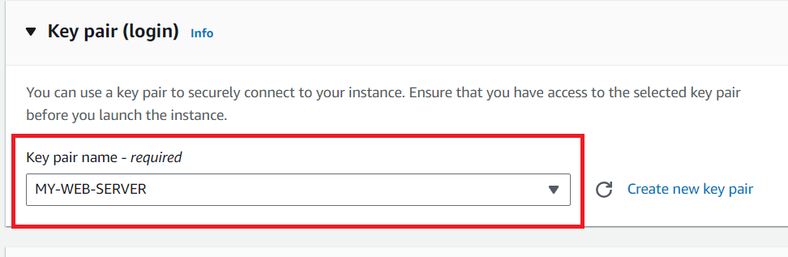

**Step 5: Click** on the **“Edit”** inthe **“Network Settings”.**



**Step 6: Choose** the **“other created subnet (subnet-0069fe2e6e5729baa)”** or **“Zone_C”, where** the **“Availability Zone”** isthe **“ap-south-1c”.**

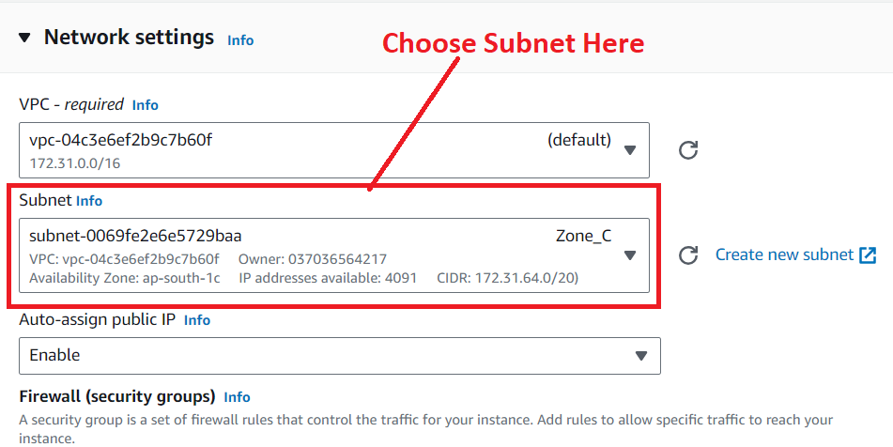

**Step 7: Choose** the **“Select Existing Security Group”** in the **“Firewall (security groups).**



**Step 8: Remain** the **“Configure Storage”** as **it is.**



**Step 9: Click** on the **“Advance Details” & put** this **user data** over **here.**

**#!/bin/bash**

**# Use this for your user data (script from top to bottom)**

**# install httpd (Linux 2 version)**

**yum update -y**

**yum install -y httpd**

**systemctl start httpd**

**systemctl enable httpd**

**echo "<h1>Hello World from $(hostname -f)</h1>" > /var/www/html/index.html**





**Step 10: Click** on the **“Launch Instance”.**



**Step 11: Your instance** will be **successfully launched. Click** onthe **“Hyperlink Id”.**

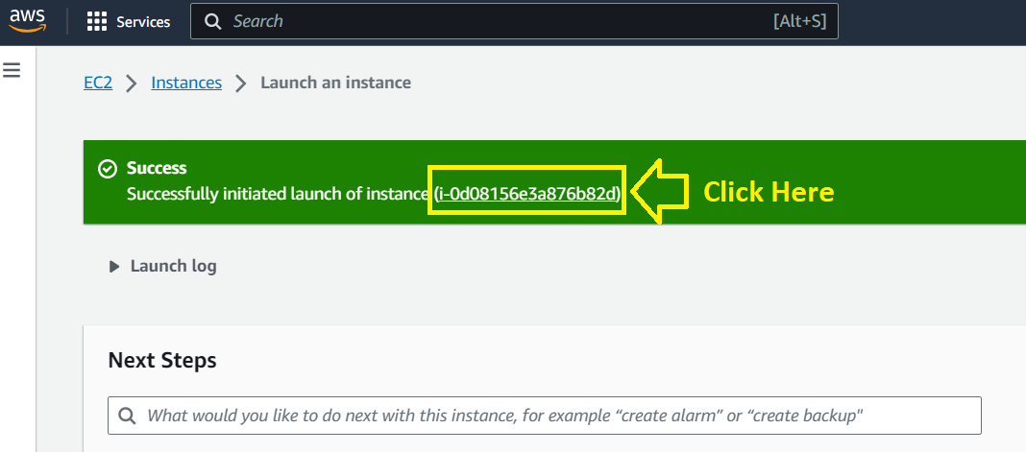

**Step 12: Your instance** will be **shown** as **“Running”** from **moving** to **“Pending”** now.

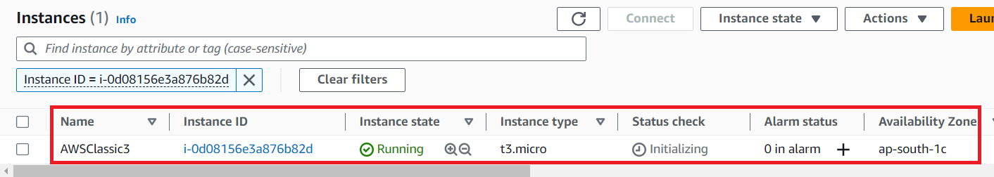

**Step 13: Select** the **Instance** & **you** will **get** your **“Public IPv4 address”. Copy** this **public IP address.**

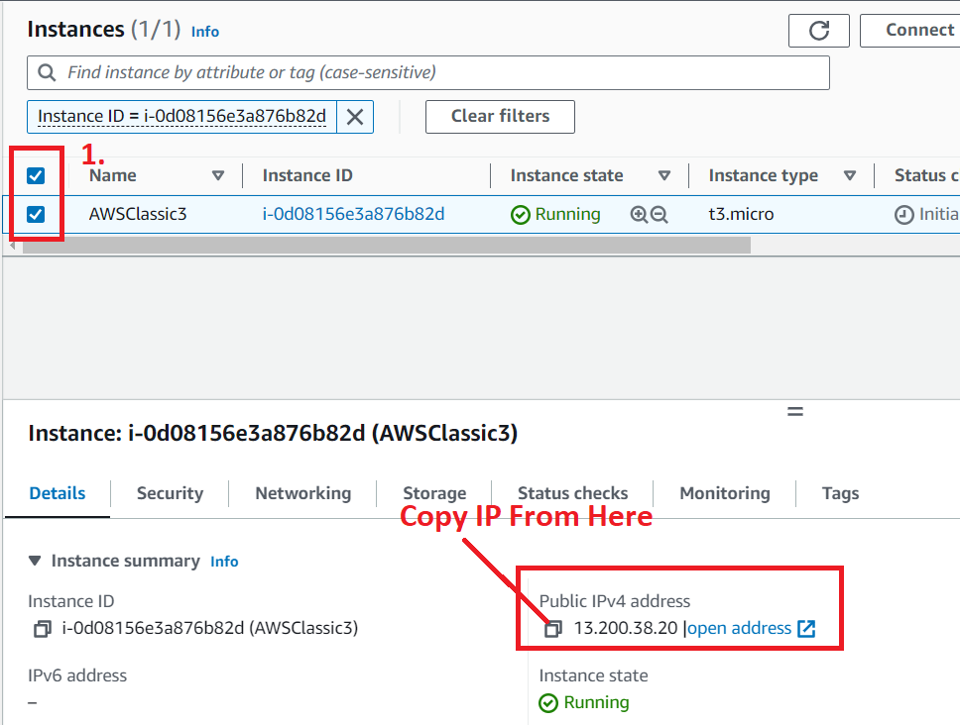

**Step 14: Paste** the **IP Address** in the **browser address bar** & **you** will **have successfully installed** your **httpd server.**

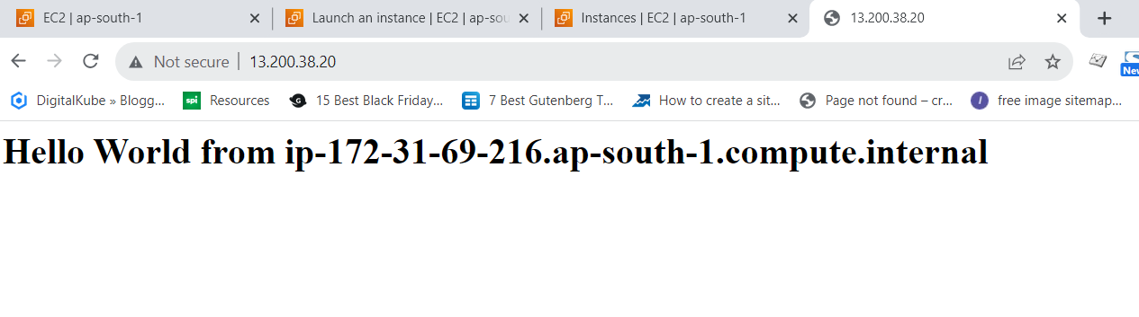

**b. Create a Classic Load Balancer**

**Step 1: Go** tothe **“Load Balancers”** in the **“Load Balancing”.**

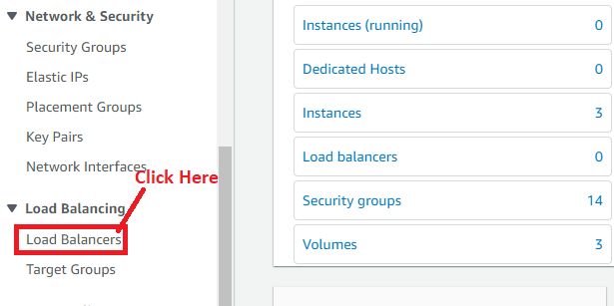

**Step 2: Click** on the **“Create load balancer”.**

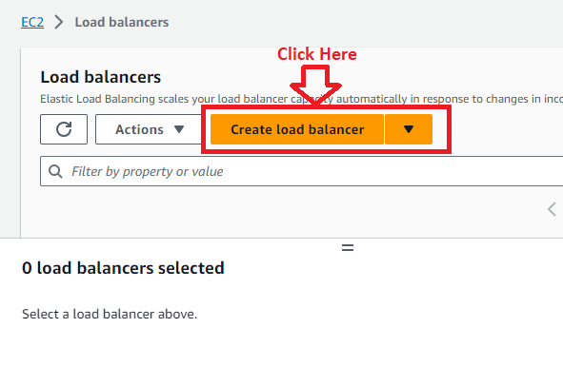

**Step 3: Go** tothe **“Classic Load Balancer-previous generation”.**

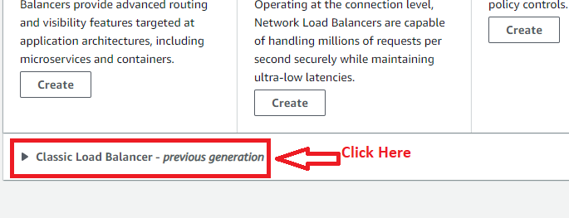

**Step 4: Click** onthe **“Create”.**

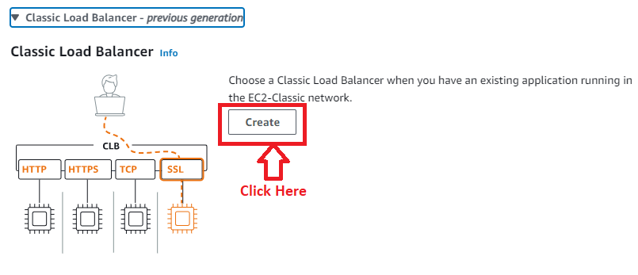

**Step 5: Choose** the **“Load Balancer Name”** as **“AWSClassicLoadBalancer”** & **Scheme** as **“Internet Facing”** in **“Basic Configuration”.**

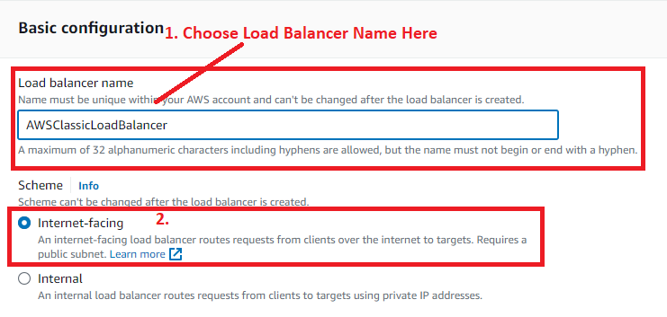

**Step 6: a. In** the **“Network Mapping”, choose** the **“ap-south-1a (aps1-az1)”** & the **subnet** will be **remain same.**

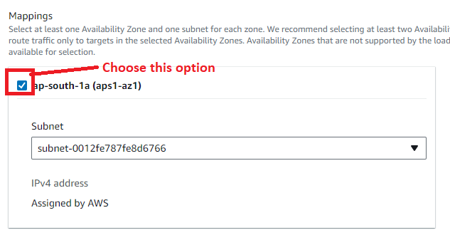

**b. Select** the **“ap-south-1b (aps1-az3)” & select** the **subnet present** in this **zone. We** have **created “Zone_B”** in this **region** as a **subnet.**

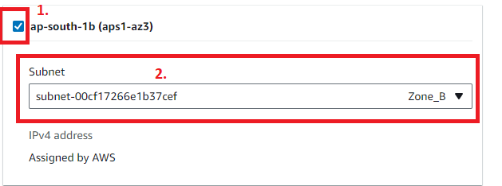

**c. Select** the **“ap-south-1c (aps1-az2)”** & **select** the **subnet present** in this **zone. We** have **created** the **“Zone_C”** in this **region** as a **subnet.**

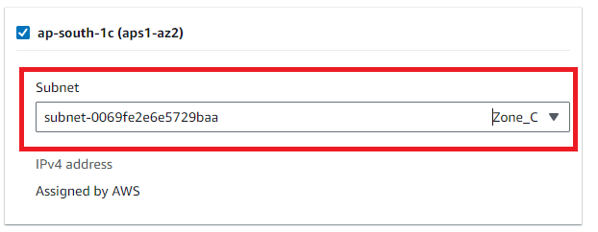

**Step 7: Choose** the **“Security Groups”** as **“launch-wizard-2”, which** youhave **created during** the **ec2 instance creation.**

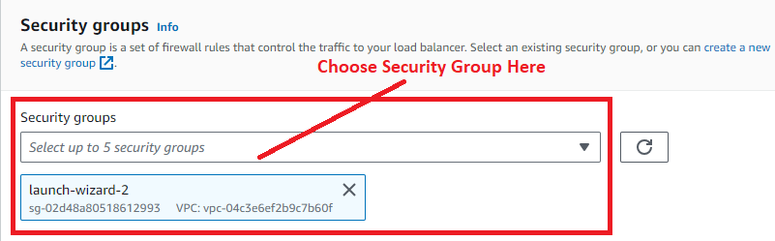

**Step 8: Go** tothe **“Instances’** & **click** onthe **“Add Instances”.**

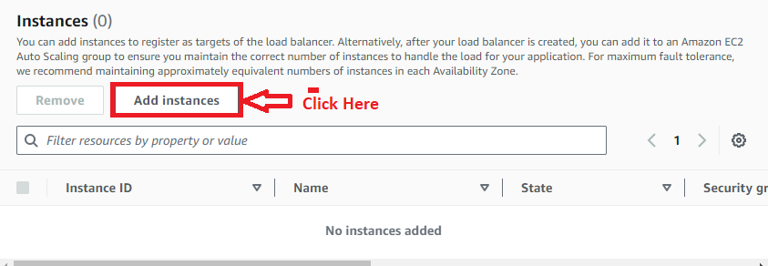

**Step 9: All** the **available instances** will be **shown** in the **“Add Instances”. Tick** the **Instance Id box** & **all** the **instances** will be **selected. Click** on the **“Confirm”.**

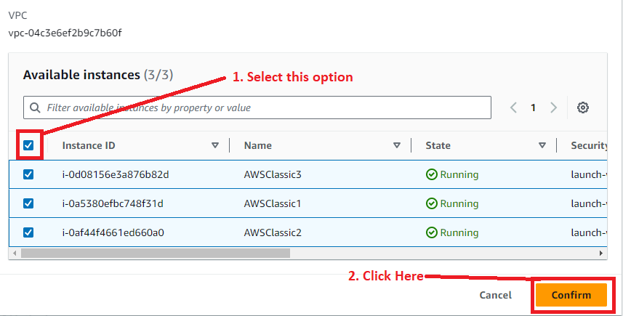

**Step 10: Leave** the **other settings** by **default** & **click** onthe **“Create load balancer”.**

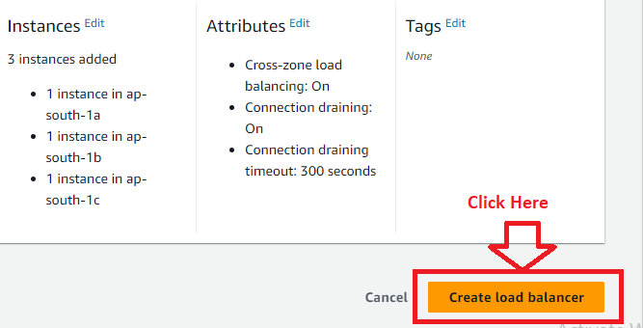

**Step 11: The Classic Load balancer** will be **successfully created** as **“AWSClassicLoadBalancer”. Click** onthe **“View load balancer”.**

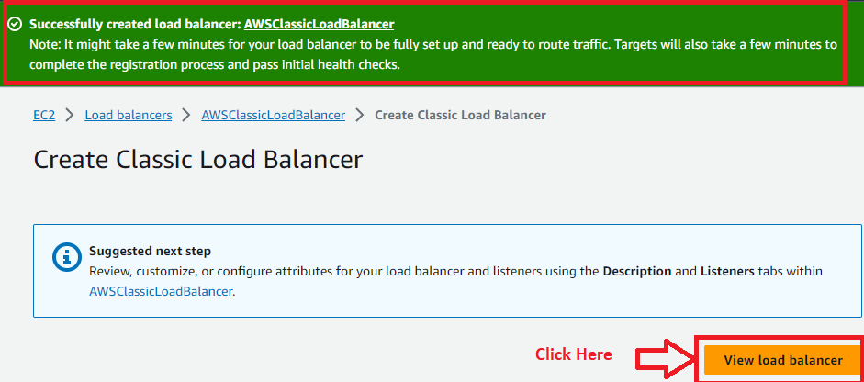

**Step 12: Your load balancer** will be **shown. Click** onthe **“AWSClassicLoadBalancer”.**

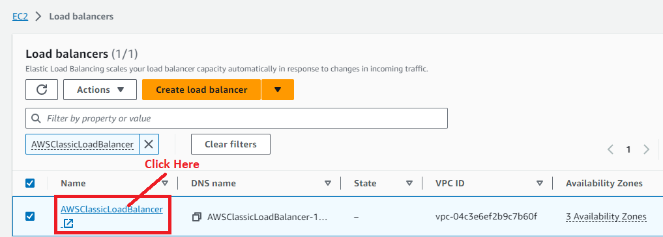

**Step 13: Copy** the **DNS Name (AWSClassicLoadBalancer-1224976682.ap-south-1.elb.amazonaws.com).**

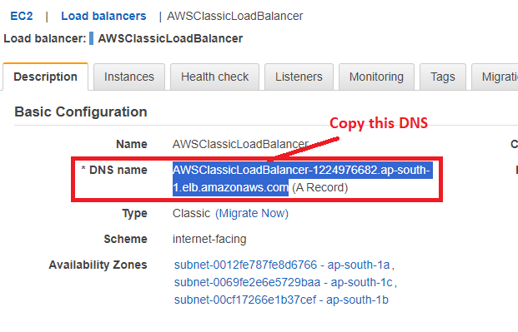

**Step 14: Paste** the **DNS Name** in the **browser address bar.**

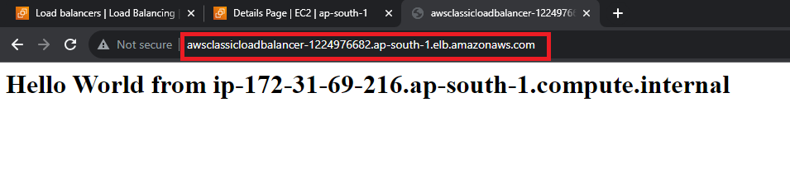

**Step 15: When we refresh** the **browser again** & **again, you** will **notice all** the **webpages created** on **multiple instances shown like this:**

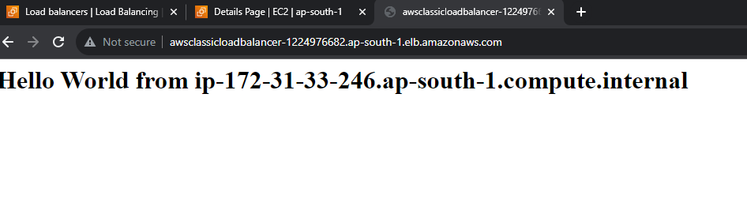



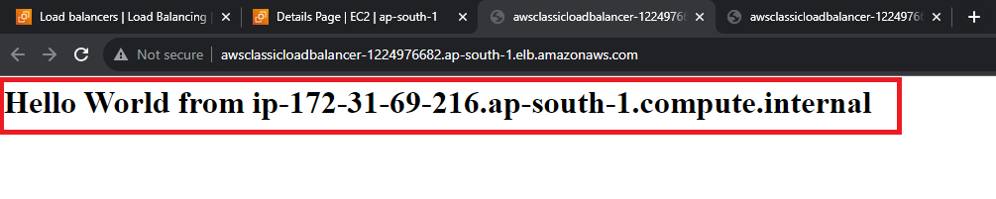

**2. Migrate Classic Load Balancer to Application Load Balancer**

For **migrating** the **Classic Load Balancer** to **Application load balancer**, you need the **target groups**. Because **Application load balancer** supports **path based routing** while **Classic Load Balancer** does not **support**.

When you **migrate** the **Classic Load Balancer** to **Application load balancer**, **target group** will be **automatically created** by **AWS**.

And, **when** you **refresh** the **DNS multiple times**, the **application load balancer** will **display** the **same web pages again** & **again, which you** have **created** on **multiple EC2 Instances** for **Classic Load Balancer.**

**Step 1: To migrate** the **classic load balancer** to **application load balancer, go** to **“Migration”.**

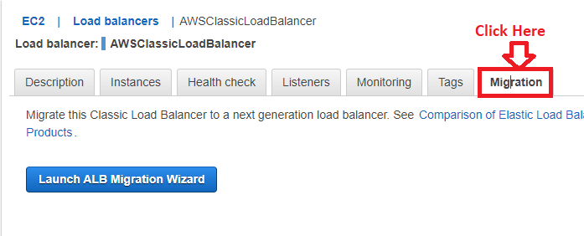

**Step 2: Click** on the **“Launch ALB Migration Wizard”.**

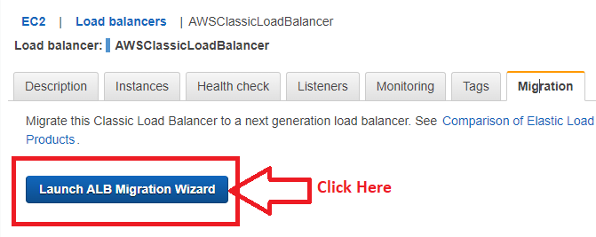

**Step 3: You** will be **redirected** to the **“Review” section. You** can **view** your **application load balancer settings** here**. Click** onthe **“Create”.**

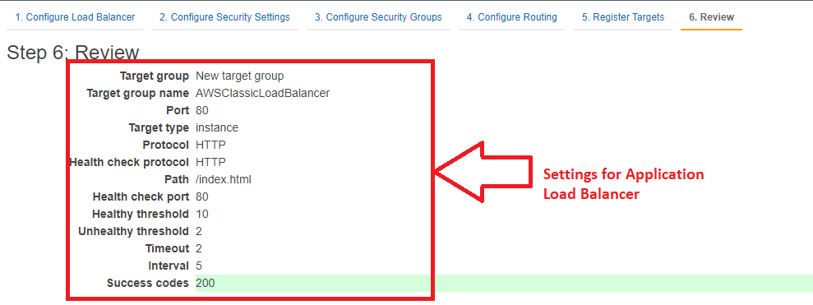

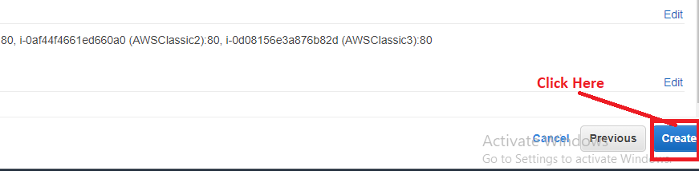

**Step 4: Your Application load balancer** will be **successfully created. A success message** will be **shown like this:**

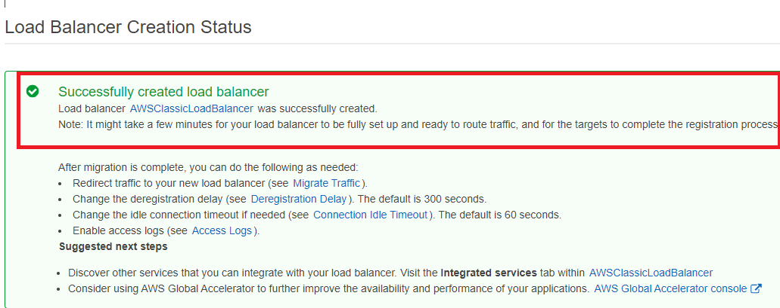

**Step 5: Click** on **“Close”.**

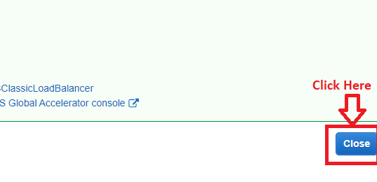

**Step 6: Now, you** have **seen two load balancers, while** the **second one** isyour **“Application Load Balancer” in** the **State** as **“Active”. Click** on **this load balancer (AWSClassicLoadBalancer).**

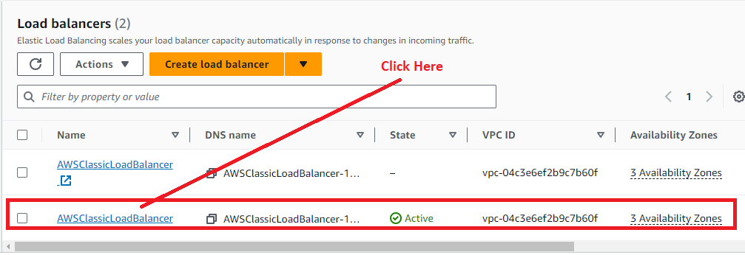

**You** can **view** the **type** of **these load balancers** by **scrolling** in the **right side.**

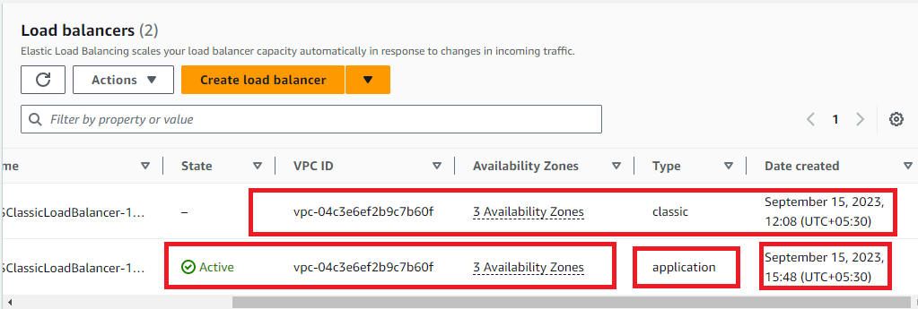

**Step 7: Copy** the **DNS name.**

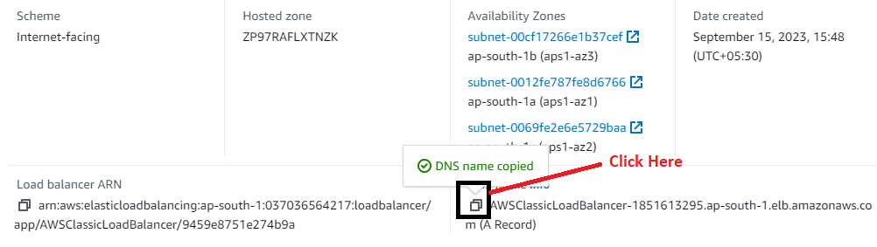

**Step 8: Paste** the **DNS Name** in the **browser address bar** & **refresh multiple times, your different web pages** will be **shown which deployed** on **three different EC2 instances.**

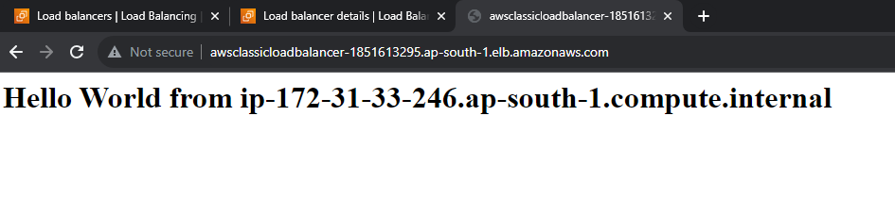

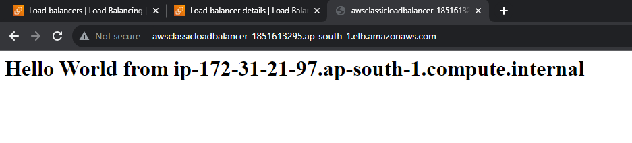

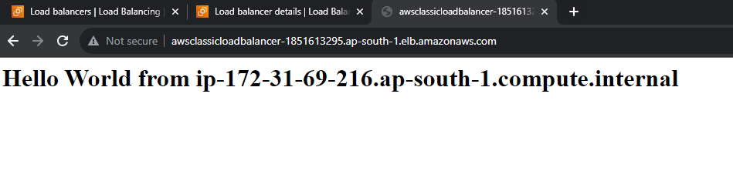

**Step 9: Go** tothe **“Target Groups”** & **you will notice** the **target group automatically created** for **Application Load Balancer.**

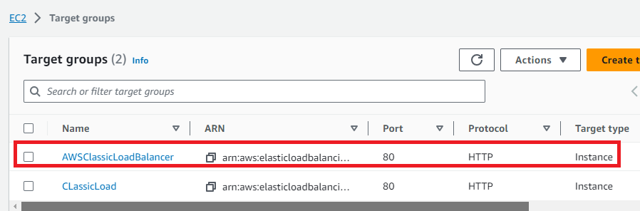

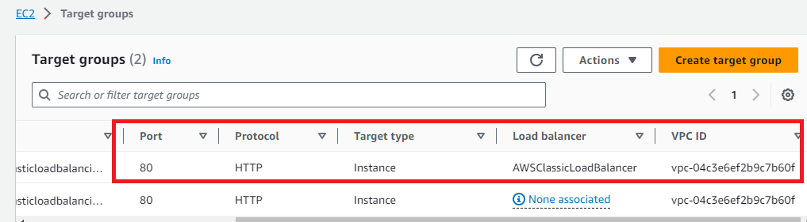

**This means,** your **“Classic load balancer”** will be **successfully migrated** to **“Application load balancer”.**

***“Remove all the load balancer by clicking on Delete because Load balancers are chargeable.”***